

School of Future Tech
CASE STUDY

Student Ranking Adjustment System

Data Structure & Algorithms (DSA)

By
Rima Maji

Index
- Introduction to the Case Study
- Problem Statement / Case Background (Abstract)
- Case Study Design
- Methods & Algorithms Technology Applied in the Case Study
- Case Study Implementation Details and Snapshots
- Results and Conclusion
- References

1. Introduction to the Case Study
This case study focuses on a Student Ranking System developed using C++. The program stores student names and scores, displays the original ranking, allows the user to update a student’s score, and then sorts the students again based on their updated scores.
The system uses a sorting technique called Bubble Sort to arrange students in descending order according to their marks. The project helps in understanding important programming concepts such as structures, arrays, functions, loops, and sorting algorithms.

2. Problem Statement / Case Background (Abstract)

Background
In schools and colleges, student rankings are updated whenever marks change. Doing this manually can take time and may also create mistakes in ranking calculation.
A computerized ranking system can make this process faster, easier, and more accurate.

Abstract
This case study presents the design and implementation of a Student Ranking System using Bubble Sort in C++. The program stores student details like names and scores, displays the ranking list, allows updating marks, and rearranges the rankings automatically.
Bubble Sort is used to compare and swap student scores until the ranking is properly sorted in descending order. The system demonstrates how sorting algorithms can be applied in academic result management systems.

3. Case Study Design

The Student Ranking System is designed in the following steps:

1. Data Storage
- Store student names and scores using a structure.
- Use an array to store multiple student records.

2. Display Function
- Show rank, student name, and score in table format.

3. Score Update
- Ask the user to enter the student name and updated score.
- Search the student record and update the marks.

4. Sorting Process
- Apply Bubble Sort to rearrange students according to scores.

5. Updated Result Display
- Display the new ranking list after sorting.

4. Methods & Algorithms Technology Applied in the Case Study

Bubble Sort Algorithm
Bubble Sort compares two nearby student scores at a time.
- If the first student has a lower score than the next student, their positions are swapped.
- This process repeats until all students are arranged from highest to lowest marks.

Concepts Used
- Structures
- Arrays
- Functions
- Loops
- Conditional Statements

Technology Stack

Programming Language

C++

Development Environment

VS Code / Turbo C++ / Any C++ Compiler

Input & Output

Console-based input and output

5. Case Study Implementation Details and Snapshots

The implementation is divided into different parts:

1. Student Structure

The Student structure stores:

Student name

Student score

2. Display Function

The display() function prints:

Rank

Name

Score

3. Bubble Sort Function

The bubbleSort() function sorts the students in descending order according to marks.

4. Main Function

The main function:

Stores 5 student records

Displays original ranking

Updates marks

Sorts data again

Displays updated ranking

Snapshots to Include

Original Ranking Output

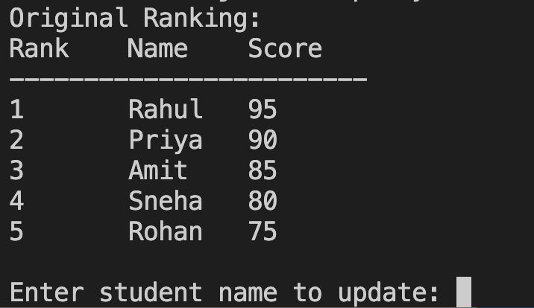

Enter Student Name and New Score
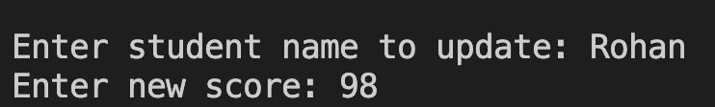

Score Updated Message

Updated Ranking Output

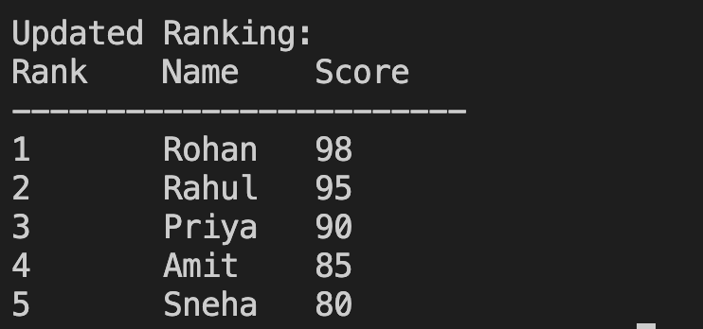

6. Results and Conclusion

Results
The program successfully:
- Stores student records
- Updates marks
- Rearranges rankings automatically
- Displays the updated ranking list correctly

Conclusion
This case study demonstrates how Bubble Sort can be used in a simple student ranking system. The project improves understanding of sorting algorithms and basic C++ concepts like structures, arrays, loops, and functions.
The system is simple, user-friendly, and useful for learning academic result management.

7. References
- C++ Programming Concepts
- Bubble Sort Algorithm
- Arrays and Structures in C++
- Console Input and Output in C++
- Basic Data Sorting Techniques
- GitHub Link
Jiya https://github.com/JIYAJANA07/DSA_Mini_Project.git
Shubh https://github.com/shubhsaraswat1414-lgtm

